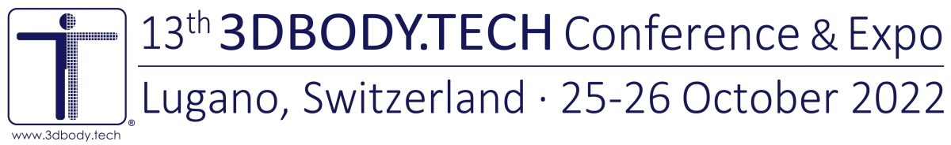
3DBODY.TECH 2022 - POST CONFERENCE REGISTRATION FORM
Please save this filled form as docx or pdf file and send it to the conference office at info@3dbody.tech.
You will then receive by e-mail an invoice with details for the payment of the due registration fees.
Please fill with your personal details:
Title (Mr/Ms/Dr/Prof):
First (given) name:
Last (family) name:
Affiliation/Company:
Role/Function:
Address:

Email:
Important: please provide the email address which serves as login to access the online conference platform.
Check this box if you do NOT consent to have your name on the list of attendees, which
will be made available to the participants of the 3DBODY.TECH Conference and Expo.
Our email policy: email addresses will NOT be made available/distributed to other parties.
Please select your registration and preferred payment:
Post conference registration:
300 CHF, access to the online conference platform, 30 days
The prices are indicated in Swiss Francs (CHF) and are inclusive of taxes when/if applicable.
Payment method:
Bank transfer with IBAN & SWIFT/BIC on CHF/EUR/USD Swiss bank account
Credit card (VISA, MasterCard, AMEX, Diners, UnionPay) by secure e-payment, +6% fees
PayPal payment system, +6% fees
Preferred currency of the invoice and payment (AMEX, Diners, UnionPay credit cards: CHF only):
CHF (Swiss Francs), EUR (Euro), USD (US Dollars)
Notes:
• The registration fees include: access to the online conference platform with all its contents,
a copy of the conference proceedings.
• The online conference platform allows to access all recorded live technical sessions, all the recorded exhibitors live demonstrations, all single pre-recorded presentations and to use tools for contacting and networking with attendees, speakers, exhibitors.
• Post conference attendees will be listed and appear as participants in the online conference platform.
Discount codes, additional notes/comments:
Conference Office:
HOMETRICA CONSULTING - Dr. Nicola D’Apuzzo, Contrada Maggiore 2, 6612 Ascona, Switzerland
E-mail: info@3dbody.tech, Tel: +41.91.791.55.24

